**installing pir motion to esp8266-01 (guide)**

info: in this step by step guide I will explain how to install a pir motion sensor to esp8266-01. There will of course be pictures to help you with this guide. The photos also make the guide shorter and clearer for the person who wants to perform this installation.

Step 1:

What do you need:

1x Pir motion sensor

1x Esp8266-01

3x Jumping wires (female to female)

1x micro usb cable

Step 2:

First install the cables with the sensor and the esp 8266-01. For this installation process you must use the jump wires (female to female). The installation process is shown in this photo:

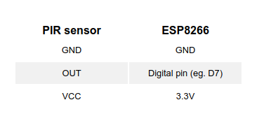

Step 3:

Install the Arduino IDE (Integrated development environment). You can download it for Mac OS X, Windows and Linux.

Step 4:

Start the Arduino application and open Preferences

Enter http://arduino.esp8266.com/stable/package_esp8266com_index.json into the Additional Board Manager URLs. If you need more than one, they can be separated with commas

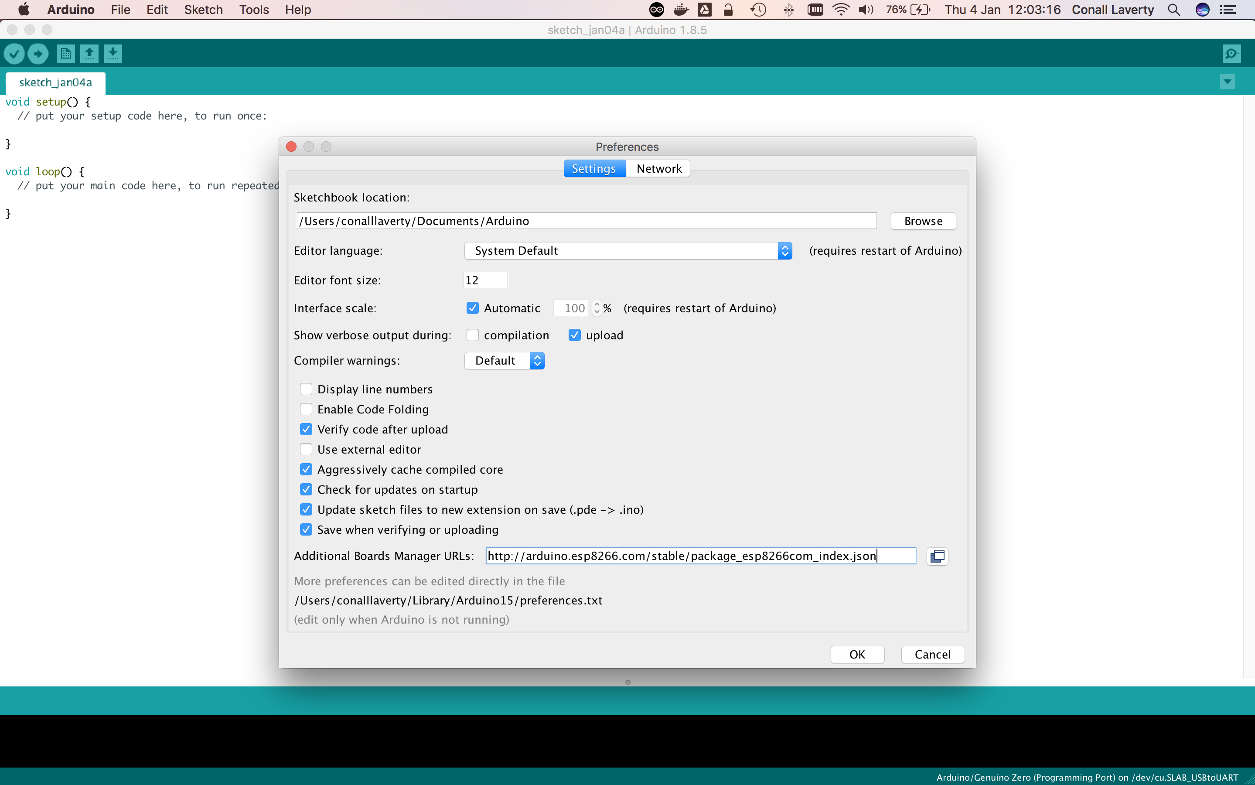

Go to Tools > Board > Boards Manager

Search for esp8266. When found, click Install

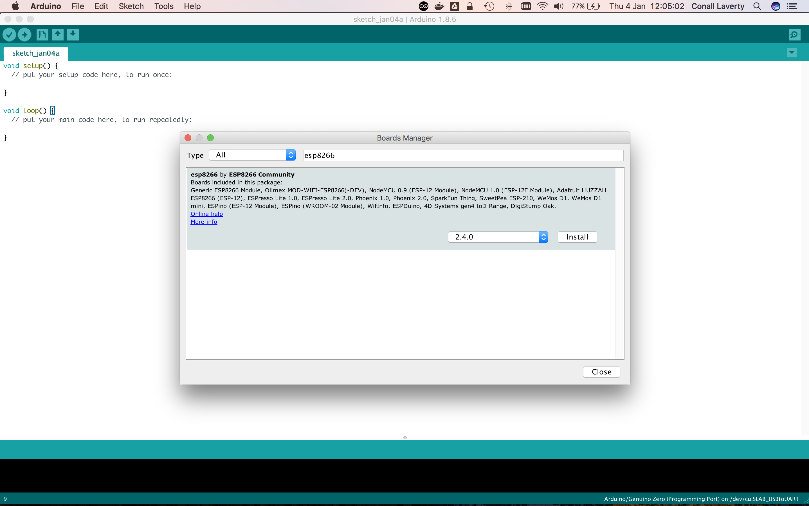

Plug in the ESP8266 to your USB port

Select your ESP8266 board type by going to Tools > Board, then choosing your type. For this example, you can use NodeMCU 1.0 (ESP-12E Module)

Check that Upload Speed is set to 115200

Select the correct port for the board

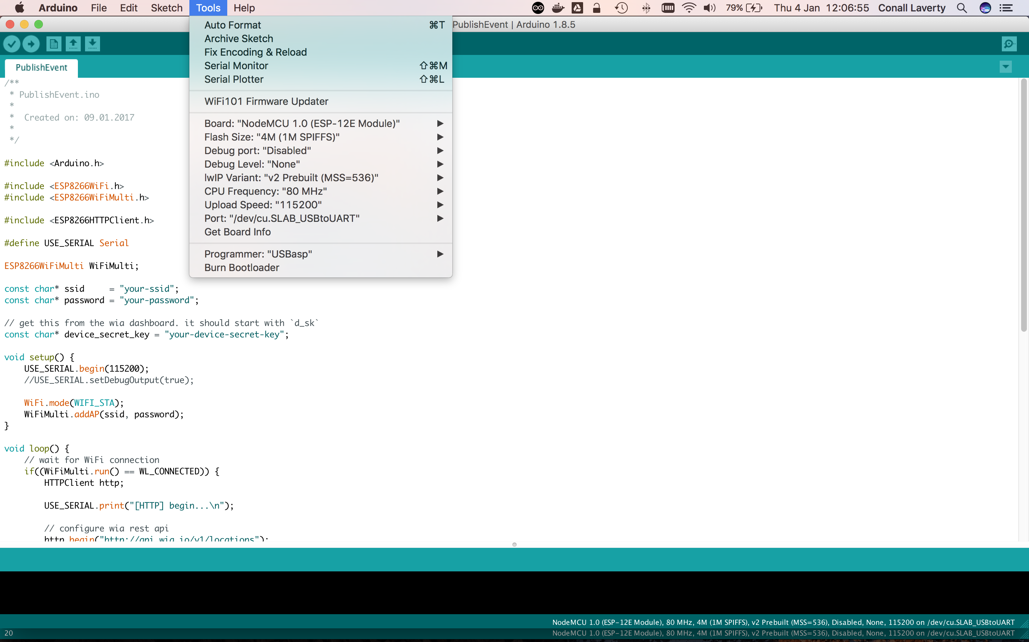

step 5:

Now that everything is set up, here's a basic sketch you can use to get started with detecting motion:

**int** sensor = 13; // Digital pin D7

**void** **setup**() {

pinMode(sensor, INPUT);

Serial.begin(115200);

}

**void** **loop**() {

**long** state = digitalRead(sensor);

**if** (state == HIGH) {

Serial.println("Motion detected!");

delay(1000);

}

**else** {

Serial.println("No motion detected.");

delay(1000);

}

}

Step 6:

Now everything should work if you have followed all these tips. If there are still problems, you have to adjust the sensitivity and then everything should work. Now you are ready to use the sensor, goodluck!!!

Dit is hoe het eind product er uit hoort te zien:

